Git commands

1. Git status

It is used to provide the status of the files whether they are commited or not

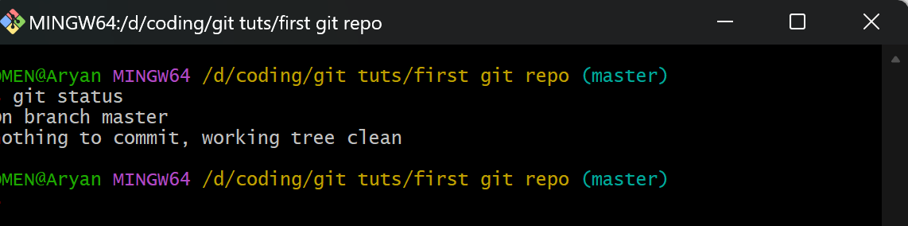

1. Git log

It provides the log of changes done by the users in the following files.

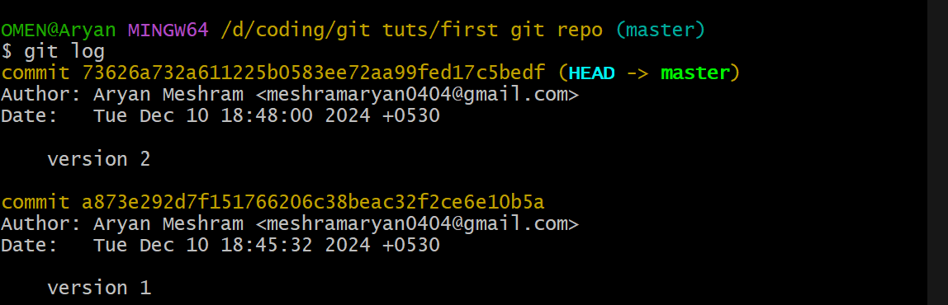

1. Git config –global user.name “your name”

Helps you to change your name for the git repository but globally and can be accessed from any folder in the system.

If global is not used then it will automatically take the systems name.

1. Git config –global user.email “[yourmail@gmail.com](mailto:yourmail@gmail.com)”

Helps you to change your email for the git repository as the above same.

1. Git init

It helps you to initialize the new git repository

1. Git add .

It helps you to stage in the files before commiting them

1. Git commit -m “hey I have done this changes in code”

Helps you to commit the file in the any code hosting website while keeping the track of changes or any version u have made